SERVER INFRASTRUCTURE PERFORMANCE MONITORING ANALYSIS
MACHINE LEARNING & DASHBOARD PROJECT

PROJECT REPORT
BY
NITHYA.R K
DATA ANALYST

UNDER THE GUIDANCE & SUPERVISION OF
MISS AMRITHA.M R

PALAKKAD, KERALA, 678702



CONTENTS

- ABSTRACT
- OBJECTIVE
- METHODOLOGY
- DATASET OVERVIEW
- DATA ANALYSIS & EDA VISUALS
- MODEL DEVELOPMENT & RESULTS
- DASHBOARD OVERVIEW
- STREAMLIT WEB APP
DEPLOYMENT
- CONCLUSION & FUTURE SCOPE

1.INTRODUCTION
Server Infrastructure Monitoring Analysis is a data analytics and machine learning project that focuses on monitoring server performance and identifying potential performance issues. Servers play a vital role in storing data, running applications, and managing network services. Maintaining their performance is essential for ensuring system reliability, availability, and efficiency.
This project analyzes key server performance metrics such as CPU usage, memory usage, disk utilization, network latency, response time, and error count. Using Python, machine learning algorithms are applied to identify patterns in server performance data and predict potential performance issues.
The project also uses Excel to create interactive dashboards that visualize server performance, highlight critical metrics, and support data-driven decision-making. By identifying potential issues early, this system can help improve server reliability, reduce downtime, and support efficient infrastructure management.

2.ABSTRACT
The Server Infrastructure Monitoring Analysis and Performance Issue Prediction project aims to analyse server performance and predict potential infrastructure issues using data analytics and machine learning techniques. Servers are essential for managing applications, storing data, and supporting network services. Poor server performance can lead to system downtime, slow response times, and reduced operational efficiency. Therefore, continuous monitoring and early identification of performance issues are important for maintaining reliable server operations.
This project analyses server performance metrics such as CPU usage, memory usage, disk utilization, network latency, response time, error count, and active connections. Python is used for data cleaning, exploratory data analysis, feature selection, and machine learning model development. Classification algorithms such as Logistic Regression, Decision Tree, Random Forest, and XGBoost are used to predict whether a server is experiencing a performance issue. Model performance is evaluated using accuracy, precision, recall, F1-score, and confusion matrix, along with cross-validation.
Excel is used to develop interactive dashboards that present server performance trends, resource utilization, and predicted performance issues. The proposed system helps identify potential server problems, supports proactive monitoring, and provides useful insights for infrastructure management. The project demonstrates how machine learning and data visualization can be combined to improve server monitoring and support data-driven decision-making.

3.OBJECTIVES

- The main objective of this project is to identify the performance issue.
- To analyse and identify the performance issue.
- To perform Exploratory Data Analysis (EDA) to analyse patterns and understand data types
- To develop and evaluate Machine Learning models for predicting performance issue.
- To visualize insights through dashboards.

4.METHODOLOGY
Step1: Data Collection
- Collect Server infrastructure details.
- Important datas include Server type, Operating system, CPU usage, Memory usage, Disk usage, Network in mbps, Network out mbps, Network latency ms, Active connection, Request count, Error count, Process count, Uptime hours, Temperature C and Hour.
- Step 2: Data Preprocessing
- Check for missing values and duplicates.
- Identify and handle outliers.
- Correct data types and prepare the dataset for analysis.
Step 3: Exploratory Data Analysis (EDA)
- Understand server resource utilization.
- Analyse distribution of performance metrics.
- Identify relationship between server metrics.
- Examine the distribution of normal and problematic servers.
- Identify performance patterns that help predict server issues.
Step 4: Machine Learning Model Development
Implemented Machine Learning models:
- Logistic Regression
- Random Forest
- Decision Tree Classifier
- XGBoost
Step 5: Model Evaluation
Compare the models using classification metrics:
- Accuracy
- Precision
- Recall
- F1 score
- Confusion matrix
Step 7: Prediction and Feature importance
- Use the selected model for server performance prediction and analyse resource utilisation.
- Analyse feature importance to identify the most associated infrastructure metrics.
Step 8: Dashboard Development
- Developed an interactive dashboard using Excel to visualize the performance issue distribution and key performance indicators.

5.DATASET OVERVIEW
- Source: Server Infrastructure dataset
- Key Features:
  - Server Type
  - Operating System
  - CPU usage
  - Memory usage
  - Disk usage
  - Response time
  - Active connections
  - Request count
  - Error count
  - Uptime hours
- Target Variable: Performance issue

6.DATA ANALYSIS AND EDA VISUALS

Key Observations:
- Features like CPU usage, memory utilization, response time are used to predict server performance issue.
- Feature importance analysis are used to determine the top features for performance issues.

Visualisation used:
- Bar Chart
- Histogram
- Box Plot
- Confusion Matrix

7.MODEL DEVELOPMENT AND RESULTS
Models Applied:
- Logistic Regression
- Random Forest Regression
- Decision Tree Classifier
- XGBoost Regression

Best Model: XGBoost
Achieved the best F1 score when testing the model.

Important Predictive Factors:
- Response Time
- CPU usage
- Memory usage
- Windows server
- Process count
- Disk usage

8.DASHBOARD OVERVIEW
The interactive dashboard presents

9.STREAMLIT WEB APP DEPLOYMENT
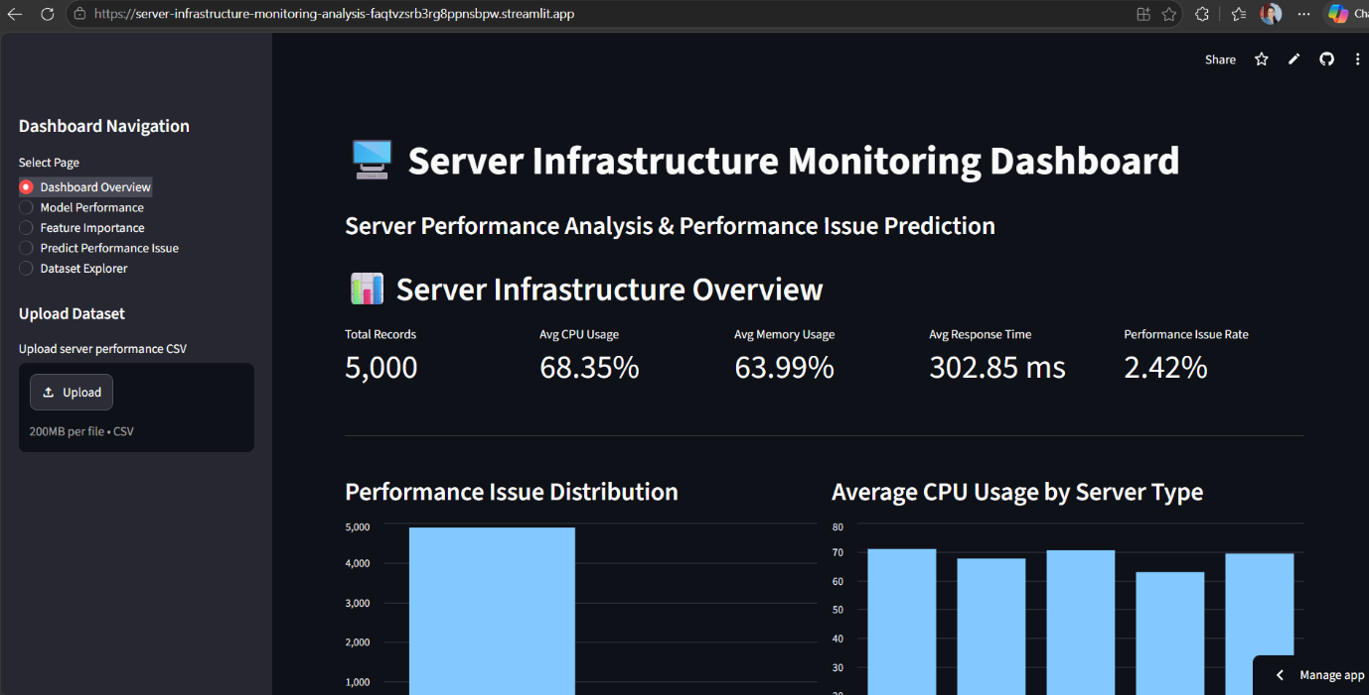
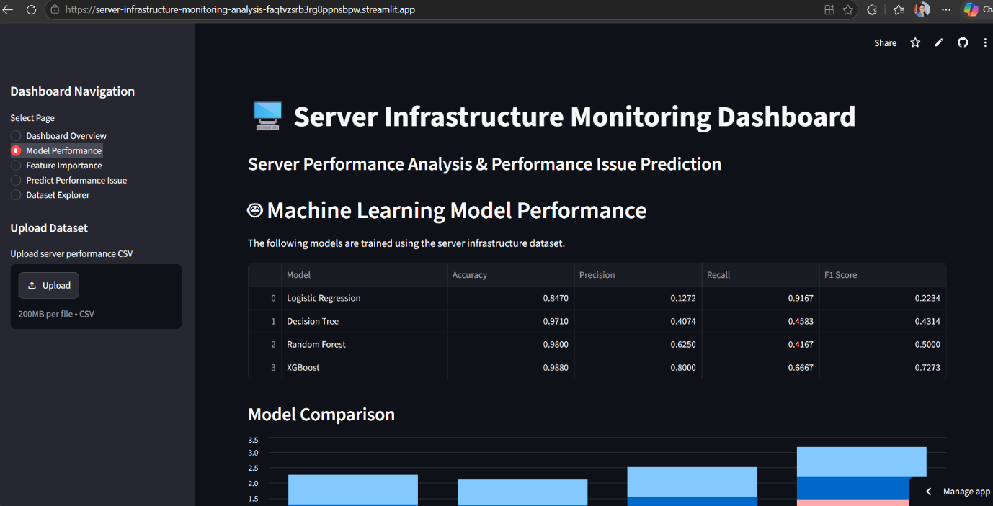

https://server-infrastructure-monitoring-analysis-faqtvzsrb3rg8ppnsbpw.streamlit.app/
The best-performing machine learning model was successfully deployed as a Streamlit Web Application. The web app allows the users to upload the dataset and check the server issues and model performance.

10.CONCLUSION AND FUTURE SCOPE
Conclusion:
The project demonstrates how machine learning and data visualization can support server monitoring, help identify potential performance problems, and improve infrastructure management. It provides a foundation for proactive monitoring and data-driven decision-making.

Future Scope:
- Real time Server monitoring.
- Early warning and alert system
- Predictive maintenance and root cause analysis to help administrators troubleshoot problems.

